**AN   E-COMMERCE   WEBSITE   ( SINO SHOP ) SOFTWARE   DESIGN   DOCUMENT.**

**DONE BY:.  *KOM DARYL***and   ***SIMON NGWONJU.***

**EDITING DATE:.  *(****23/07/22****).***

**TABLE OF CONTENT**

[INTRODUCTION](https://docs.google.com/document/d/1QKAXFQmkb2bwBCS7UAwcN_OLuMjOAZ-Q8azHAp0JOU8/edit#heading=h.pnmyi5v4unu7)

[Purpose](https://docs.google.com/document/d/1QKAXFQmkb2bwBCS7UAwcN_OLuMjOAZ-Q8azHAp0JOU8/edit#heading=h.z337ya)

[Scope](https://docs.google.com/document/d/1QKAXFQmkb2bwBCS7UAwcN_OLuMjOAZ-Q8azHAp0JOU8/edit#heading=h.z337ya)

[Overview](https://docs.google.com/document/d/1QKAXFQmkb2bwBCS7UAwcN_OLuMjOAZ-Q8azHAp0JOU8/edit#heading=h.z337ya)

D[efinitions and Acronyms](https://docs.google.com/document/d/1QKAXFQmkb2bwBCS7UAwcN_OLuMjOAZ-Q8azHAp0JOU8/edit#heading=h.z337ya)

[SYSTEM ARCHITECTURE](https://docs.google.com/document/d/1QKAXFQmkb2bwBCS7UAwcN_OLuMjOAZ-Q8azHAp0JOU8/edit#heading=h.twv4mbggesti)

[functions, and accounting.](https://docs.google.com/document/d/1QKAXFQmkb2bwBCS7UAwcN_OLuMjOAZ-Q8azHAp0JOU8/edit#heading=h.z337ya)

[USE CASE:](https://docs.google.com/document/d/1QKAXFQmkb2bwBCS7UAwcN_OLuMjOAZ-Q8azHAp0JOU8/edit#heading=h.g88xmq55tbwy)

[3.2 Design rationale](https://docs.google.com/document/d/1QKAXFQmkb2bwBCS7UAwcN_OLuMjOAZ-Q8azHAp0JOU8/edit#heading=h.fpmbhuc71chk)

[DATA DESIGN](https://docs.google.com/document/d/1QKAXFQmkb2bwBCS7UAwcN_OLuMjOAZ-Q8azHAp0JOU8/edit#heading=h.z337ya)

[Data Description](https://docs.google.com/document/d/1QKAXFQmkb2bwBCS7UAwcN_OLuMjOAZ-Q8azHAp0JOU8/edit#heading=h.xb0ixcyj43lj)

Dat[a Dictionary](https://docs.google.com/document/d/1QKAXFQmkb2bwBCS7UAwcN_OLuMjOAZ-Q8azHAp0JOU8/edit#heading=h.z337ya)

[COMPONENT DESIGN](https://docs.google.com/document/d/1QKAXFQmkb2bwBCS7UAwcN_OLuMjOAZ-Q8azHAp0JOU8/edit#heading=h.z337ya)

[HUMAN INTERFACE DESIGN](https://docs.google.com/document/d/1QKAXFQmkb2bwBCS7UAwcN_OLuMjOAZ-Q8azHAp0JOU8/edit#heading=h.wd3qjo3as3z3)

[Screen Images](https://docs.google.com/document/d/1QKAXFQmkb2bwBCS7UAwcN_OLuMjOAZ-Q8azHAp0JOU8/edit#heading=h.z337ya)

[REQUIREMENTS MATRIX](https://docs.google.com/document/d/1QKAXFQmkb2bwBCS7UAwcN_OLuMjOAZ-Q8azHAp0JOU8/edit#heading=h.z337ya)

**INTRODUCTION**

A software design document (SDD) is the representation of a software design that is to be used for recording design information, addressing various design concerns and communicating that information to design stakeholders. An SDD usually accompanies an architecture diagram with pointers to detailed feature specification of small pieces of the design. The SDD of the sinoshop will show a clear architectural design of the website and how the website will look like from the front end view that's the beauty of the website.

**Purpose**

The purpose of this SDD on the sino shop website is to collect and analyze all assorted ideas that have come up to define the system. Also, it describes the product characteristics, architecture, functional and non functional requirements present in the website. The SDD will also give the responsibilities of each team members in terms of doing and accomplishing their goals toward the website's view. SDD also gives information necessary for the website in details.

**Scope**

This document (SDD) is for an E-commerce website which will help users (customers) to purchase their products from home. This document focuses on the base level of the system to the higher(critical) level of the system. The scope focuses on the company, stakeholders, application, which allows online sales, distribution and marketing of products. The SDD is aimed at specifying the designing techniques of the software to be developed which in this case is an E-commerce website. Also, the aim of the website is to facilitate the  purchasing of products online and to ease the communication between the customers and the stakeholders. The website will allow the rating of services offered by the vendors/sellers.

**Overview**

This section or part of the document shows us the broad look of the remaining parts or sections of the document. The remaining sections of the document provides a general description including human interfaces, functional requirements, product's hardware and non functional requirements of the products.

**Definitions and Acronyms**

**. *PDF*** : it means portable document formats.

**. *CRM*** : it means customer relationship management.

**. *Configurations*** : it means a product which is available or selected from a catalog and can be customized.

**. *JDBC*** : it means java database connectivity and it allows standardized database interaction and access from software products.

**. *SDD*** : software design document.

**SYSTEM OVERVIEW**

This website can differ in terms of functionalities and nature. The sino shop online has a need for an application to manage their business. This application is web based which enables the accommodation of various business functions to handle the day to day operation. Some of these Requirements include;

1. Web based application.
2. Secure
3. Database driven (**SQL**).

The system overview shows us the broad view of how the website will function when accessed. Which can be shown like that

*Sino shop website* — *registration* — *order* — pay — *receive*.

Above is a brief description of how the website will look like or function when access by a user.

**SYSTEM ARCHITECTURE**

**Architectural Design**

In this section or part of the document we are talking about the main bodies( parties) using the website and their possible roles to play. Below are some of the possible roles of the users.

1. Guest( new customer): This is a visitor which has no account in the website. This visitor can browse through the website "sino shop" and until the account is created , this user cannot purchase products, or make request  information. But this user can create an account.
2. Administrator: The administration user inherit all functions from the registered user , but can also change application settings, manage the store front, order supplies, perform inventory functions, and accounting.
3. Registered user: This user inherit all the functionalities of a guest, but can also order goods, check order status, make payments, and change their preferences.
4. Vendors/sellers: The vendors will add their products in the database which will be seen in the website by the users (customers).

**USE CASE:**

Diagram **1**;

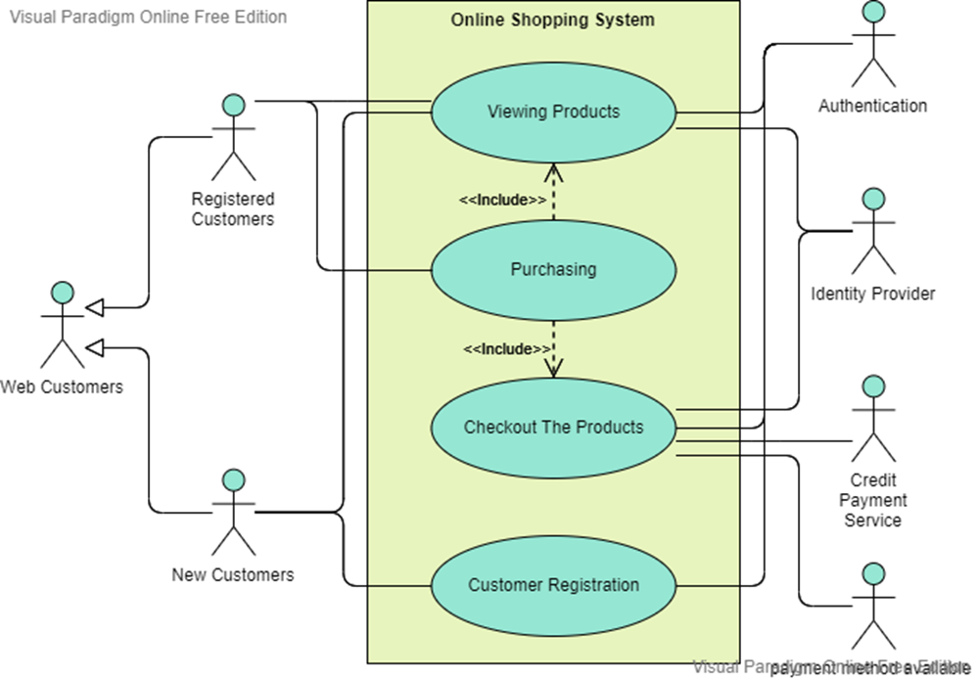

3.2 Design Rationale

       A design rationale is the explicit listing of decisions made during a design process, and the reasons why those decisions were made. Its primary goal is to support designers by providing a means to record and communicate the argumentation and reasoning behind the design process. Also, design rationale is a technique used in a design process to explain, derive, and justify decisions. It also helps us to know the relationship between the design products,the purpose and the constraints on realizing the purpose. This section deals with;

1. Design verification and evaluation
2. Design assistance
3. Design maintenance
4. Design reuse and assistance
5. Design documentation.

The main goal of this design rationale is to verify that the design meets the requirements and the designer's intent (idea about the design).

**DATA DESIGN**

Data design gives the overview of how data is going to be managed in the databases and in the website as a whole.

**Data Description**

Below is the back end view of how data is going to be managed when accessed or entered by a new customer or registered customer. This section is not not accessible by the user but only by the administrators. The email is the primary key because no two users in the website can have the same email. Since two users can have the same name, we decided to choose the email as our primary key. The email is the primary key since the user id is not yet available. Further in the data dictionary we will explain more about the data design and the attributes in details.

Diagram **2;**

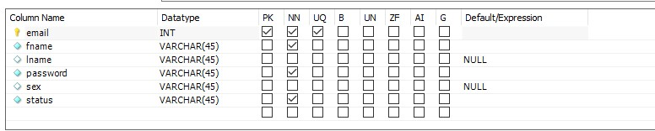

**Data Dictionary**

In this section of the SDD we will be talking about all the Requirements required in designing a database and their functions. Also to show the overview of the databases.

1. ***Information for registered users:***

|  |  |  |
| --- | --- | --- |
| **Field name** | **Data type** | **description** |
| Users id | Int | Users identification number |
| Name | varchar(60) | Users name |
| Purchase date | date | Date of purchase |
| Gender | varchar(60) | Male or female |
| Email | varchar(60) | For sending details about the products purchase. |

1. ***Information of administrators:***

|  |  |  |
| --- | --- | --- |
| **Field name** | **Data type** | **description** |
| Email | varchar(60) | emailof administrator. |
| Password | varchar(60) | A unique words known only by the administrator user. |

**COMPONENT DESIGN**

Sequence diagrams;

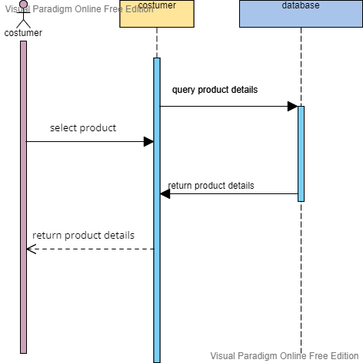

figure (i)browse catalog

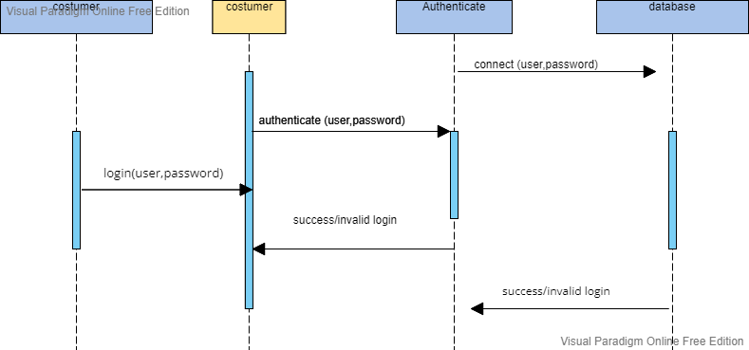

 figure (ii)registered user login

1. Class diagram for the administrator task.

Class diagram shows the classes and their relationship. It also shows the interaction between the objects at a point in time. Class diagram shows the objects of the system which are the members and what they are capable of doing( method). It is made up of three main sections.

**.** Upper section: That contains the name of the classes. It deals with the object( member).

**.** Middle section: contains the attributes of the class ( object or member?

**.** Bottom section: contains the operations or methods.

|  |
| --- |
| **ADMINISTRATOR** |
| controls and maintain the proper functioning of the system. |

**|**

|  |  |  |
| --- | --- | --- |
| **Administrator** | **transactions** | **Report generation** |
| Maintains the seller and customer record in the system. | Check out of transactions in the system. | Generates reports about the functioning of the system and it transactions. |

**|**

|  |
| --- |
| **operations** |
| 1.Remove{}  2.update{}  3.delete{}  4.add{}  5.search{}  6.create{} |

1. Class diagram for vendors/sellers task.

|  |
| --- |
| **Vendors/ sellers** |
| Controller |

**|**

|  |  |  |
| --- | --- | --- |
| **Vendors/sellers** | **Products provision** | **Report generations** |
| Controls the products | Provides products | Generate reports of the products available |

**|**

|  |
| --- |
| **operations** |
| 1.Remove{}  2.update{}  3.delete{}  4.add{}  5.search{}  6.create{} |

**HUMAN INTERFACE DESIGN**

Here, this section deals with the designing of the website which can be seen and access by the user also know as front end. It is an interface between the users and the website. It talks about the beauty of the website including it colorations, components alignment, beauty, accessibility.

**Overview of User Interface**

This section describes how users will interact with the system(website) different devices. This application design concept will allow new visitors or customers to browse through the website and create an accounts.

**Screen Images**

Figure 1; home page;

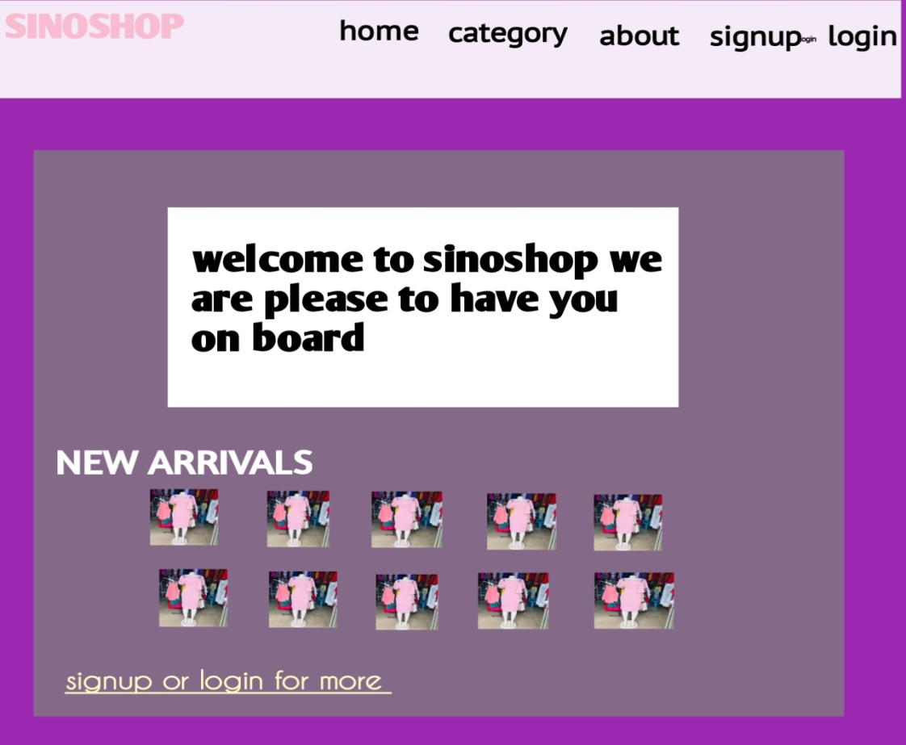

Figure 2; sign up page;

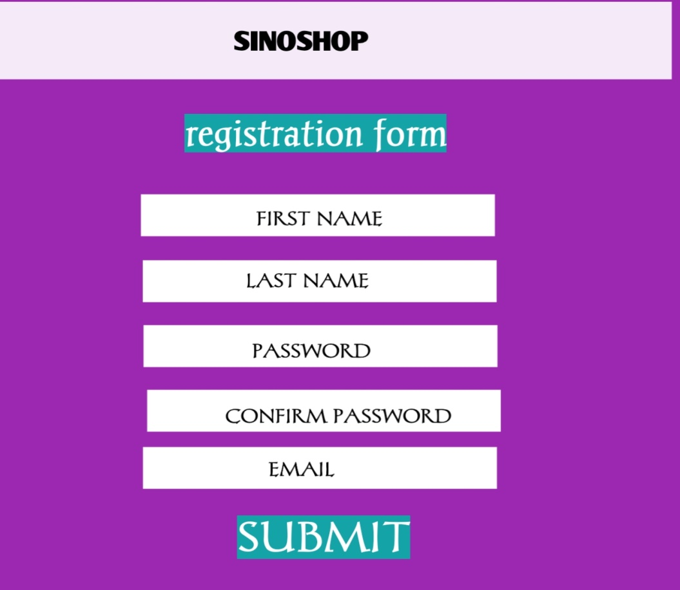

 Figure 3; users personal page;

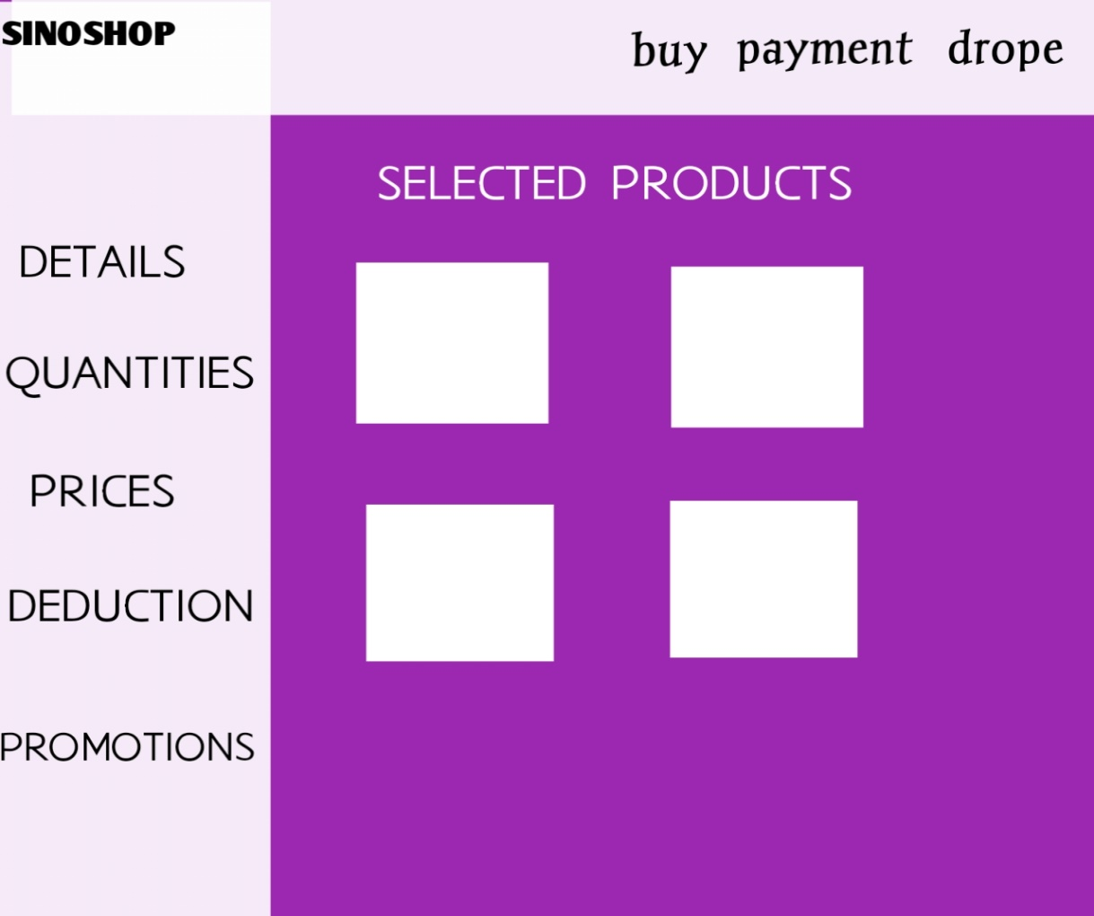

**REQUIREMENTS MATRIX**

This section deals with the overview components of the document. By specifying the project name which is an E-commerce website, the major components of the project, and also including the functional and non functional requirements of the documents.

|  |  |  |  |
| --- | --- | --- | --- |
| ***Project name*** | ***Main/ major components*** | ***Functional requirements*** | ***Non- functional requirements*** |
| E-commerce website ( sino shop) | 1) databases management  2) interfaces ( human and user interface)  3) implementation**.** | 1) administrator requirements  2) customer requirements  3database requirements. | 1. Performance 2. Security and safety 3. Software quality attributes which include( maintainability and portability.) 4. Reliability. |